A HYBRID MODEL FOR STOCK PRICE PREDICTION USING MACHINE LEARNING TECHNIQUES WITH CNN

Sarvesh S.
Department of Computer Science and Engineering
Hindustan Institute of Technology and Science
Chennai, India
sarvesh4232@gmail.com
V. Vaishnav
Department of Computer Science and Engineering
Hindustan Institute of Technology and Science
Chennai, India
vaishnavvaidheeswaran@gmail.com
Sidharth R. V.
Department of Computer Science and Engineering
Hindustan Institute of Technology and Science
Chennai, India
rvsidharth99@gmail.com
Thangakumar J
Department of Computer Science and Engineering
Hindustan Institute of Technology and Science
Chennai, India
tkumar@hindustanuniv.ac.in
Sathyalakshmi S
Department of Computer Science and Engineering
Hindustan Institute of Technology and Science
Chennai, India
slakshmi@hindustanuniv.ac.in

Abstract— Predicting the stock market can be a great tool for both long-term and short-term investors to plan and book profits, or to stop losses early than too late. Forecasting accuracy is the most important factor in selecting any forecasting methods. Research efforts in improving the accuracy of forecasting models are increasing since the last decade. The appropriate stock selections those are suitable for investment is a very difficult task. The key factor for each investor is to earn maximum profits on their investments. In order to forecast stock markets, we used deep learning and, more specifically, one of the most common recurrent neural networks: LSTM. Since the prediction of stocks cannot be easily specified, it can be separated into two parts: simple analysis (sales, revenue, income, etc.) and technical analysis (historical price, VWAP, etc.). This means multiple variables can affect stock price trends, but here we have drawn a predictive time series on the historic price of a given stock. We've been using a common RNN, Long Short Term Memory. Provided that we feed our model with the data form and that an RNN is capable of retaining data unlike the traditional feed-in of neural networks (single data points such as images might be processed only), an LSTM is the most appropriate for these kinds of problems. LSTM can quickly process a whole data series and adds a memory cell, which allows the network to link memories and feedback remotely efficiently. In this example we have generated a series of sequences in order to use time steps to predict a given price. The final predicted model will be displayed in a web-application, so this will be user-friendly.
Keywords— stock market, LSTM, price prediction, algo-trading

Introduction
The stock market refers to the collection of markets and exchanges where regular activities of buying, selling, and issuance of shares of publicly-held companies take place. Such financial activities are conducted through institutionalized formal exchanges or over-the-counter (OTC) marketplaces which operate under a defined set of regulations. Stock prices are governed by demand and supply principles, and the general goal of stocks is to maximise earnings by purchasing stocks of businesses which are expected to earn profit. The stock market is closely linked to the economy—some key performance indicators (KPIs) relies heavily on the increase in and fall in equity prices. A well-informed price estimation may, however, be made. In isolation stock prices seldom vary: action of one continues to affect a variety of other stocks. This feature of the flow of stock prices can be seen as a primary way of forecasting multiple stock prices at once. Because of the sheer amount and quantity of transactions that occur per minute, the preciseness and frequency of forecasts come into play; for instance, most stock prediction systems are delivered in a parallel manner. There are some problems and obstacles in the valuation of stocks.
- Key performance indicators (kpi’s)
Indicator Name | Indicator Description
Open | Opening price of the stock
Close | End of the day price of the stock
Low | The lowest price the stock has reached intra-day
High | The highest price the stock has reached intra-day
Volume | The total number of stocks traded during the trading session

Literature Review

Stock Price Prediction Using Long Short Term Memory
In this paper [3], a stock price prediction model using LSTM has been constructed and has been tested with 1 small-cap, 2 medium-cap, 2 large-cap companies to predict their end of the day stock price. The drawback in this system is that it can only predict the end of the day stock price and not for cumulative days.

NSE Stock Market Prediction Using Deep-Learning Models
In this paper [6], ANN has been primarily used to predict the price of a stock. They’ve used two different markets NSE and NYSE to test their model. MARUTI, HCL, AXIS BANK has been chosen to test the algorithm from NSE and Chesapak Energy (CHK) and Bank of America (BAC) have been chosen to test their algorithm from NYSE. The model discussed in the paper has worked properly for these stocks but in certain cases, other models like CNN have outperformed the chosen model. So, a hybrid model is not taken into account in this paper.

The Application of Stock Index Price Prediction with Neural Network
In this paper [1], various techniques such as Multi-Layer Perceptron (MLP), Long Short Term Memory (LSTM) and Convolutional Neural Network (CNN) have been used to predict the stock price prediction of market indices. Three indices namely S&P 500, NIKKEI 225, and CSI 300 have been chosen and the closing prices of these indices haven been predicted. The model used in this paper has been very less accurate to less developed financial markets such as CSI 300. Also, their model uses as time step 20 which will take a long time if it is to be predicted for a longer interval.

Stock Price Prediction Using Artificial Neural Networks
In this paper [2], the prediction has been done only for a single company INFRATEL using the past 400 days intraday closing price. Past 60 days data has been used for training LSTM and ANN models whereas 400 days data is used for training ARIMA and using neural networks. From the results, it’s been concluded that ANN models have been more efficient in predicting the stock price. The drawback of this system is that the price prediction for cumulative days is not done here.

Stock Price Prediction Model

Algorithm
Input: Historical stock price data from yahoo finance API
Output: Prediction Graph for stock prices based on stock price variation
- Start
- Stock data is taken from the Yahoo Finance API as a CSV file.
- The csv file is then called by pandas data-reader.
- The data is split into testing set and training set.
- LSTM and CNN neural network structure is built.
- Train the constructed network on the data.
- Use the output of the last layer as prediction of the next time step.
- Repeat steps 6 and 7 until optimal convergence is reached.
- Obtain predictions by providing test data as input to the network.
- Evaluate accuracy and loss by comparing predictions made with actual data.
- Predict the stock price for the next 5 days.
- Send the result data to front-end to display the graph.
- End.
Dataset is taken from the Yahoo Finance API when the user enters the symbol of the company. The data set contains information on the company's stock such as past closures, opens, high, low and the volume traded. From these datasets, we collect just 65% of the data. These data are used for model training. This educated data collection will be used to forecast the company's next five days stock price. The closing price of the stock is preferred as buyers must opt to buy only with the closing price of the stock. The overall working of the stock prediction model and the interaction of users with the model via the proposed web application is show below in Figure 1.
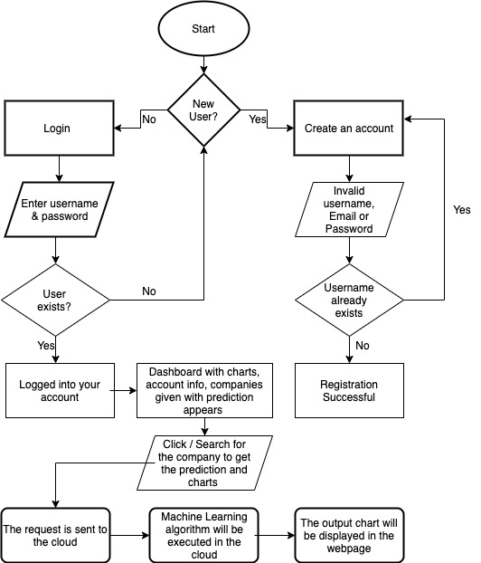
- Overall working of Stock Prediction model via the web-app

LSTM – Overview
Long Short-Term Memory (LSTM) networks are a type of recurrent neural network capable of learning order dependence in sequence prediction problems.
Each neuron of the LSTM is a memory cell capable of storing other pieces of information. If neurons in ordinary RNNs simply join the hidden condition of the former and the existing input is used to generate a new hidden condition, an LSTM neuron takes its old cell state and outputs its new cell condition. The following three components or gates are provided in an LSTM memory cell as seen in Figure 2.
- Forget Gate: The forget gate decides whether to substitute more recent knowledge on particular portions of the cell state. For areas of the cell state that are maintained, it outputs values near 1 and zero for values that should be ignored.
- Input Gate: This portion of the network is told on the circumstances under which information in the cell state should be saved (or updated) on the basis of an input (i.e. previous output of o(t-1), input x(t), and previous cell state c(t-1)).
- Output Gate: This section determines, based on the input and cell state, which information is being propagated to the next node in the network (i.e. output o(t) and cell status c(t)).
LSTM networks are therefore suitable for studying how variation in the valuation of one stock may have a long-lasting impact on the values of many other stocks. They will also determine (in a sophisticated way) how long knowledge on some historical patterns in stock prices must be stored, to help forecast possible trends in stock price variations.
Given a standard feedforward MLP network, an RNN can be thought of as the addition of loops to the architecture. The recurrent connections add state or memory to the network and allow it to learn and harness the ordered nature of observations within input sequences.
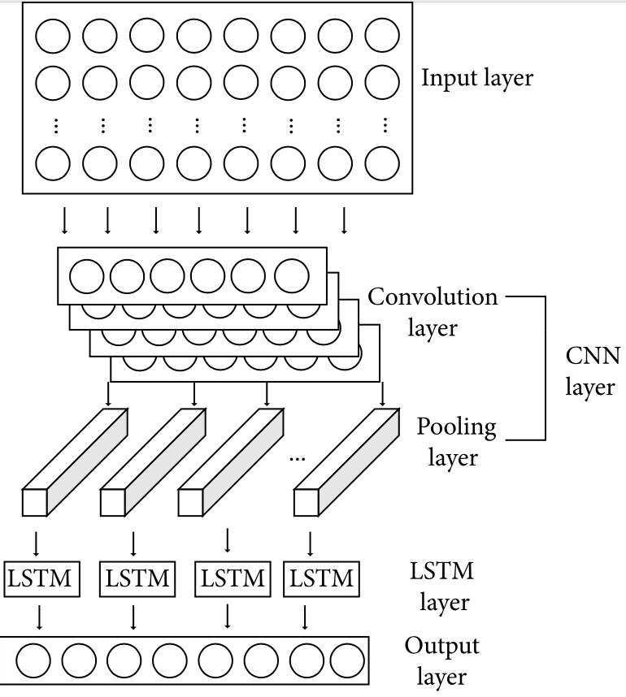
- An LSTM memory cell [5]

CNN – Overview
The Convolutional Neural Network (ConvNet/CNN) is a Deep Learning algorithm which is very similar to ordinary Neural Networks but they are made up of neurons that have learnable weights and biases., which will bring in the input representation, assign value (learnable weights and bias) to different aspects/objects at the dataset and be able to differentiate one from the other. The pre-processing involved at The ConvNet is often lower as compared to other classification algorithms. While in archaic methods filters are hand-engineered, with adequate education, ConvNets have the power to take these filters/characteristics. There are a number of convolution kernels in each core layer and their formula is indicated below. Following convolution of the convolution layer, the information features are retrieved, however, the retrieved features are very high. To unravel this problem and reduce the value of network coaching, a pooling layer is added to resize the feature dimensions after the convolution layer:
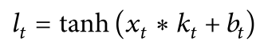[4]
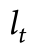output value after convolution
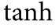 activation function
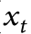 input vector
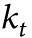weight of the convolutional kernel
bias of the convolutional kernel

CNN – LSTM – Overview
The property of CNN is to perceive the most noticeable features in the sight line, so it is commonly used in feature engineering. LSTM has the expansion feature consistent with the time series, which is commonly used in statistics. A stock forecasting model sponsored by CNN- LSTM is developed by the characteristics of CNN and LSTM. The structure diagram is presented in Figure 2 and thus CNN and LSTM are the principal structures plus an input layer, a 1-dimensional convolution layer.

Obtaining Dataset and Pre-processing
The stock data CSV file for various companies are fetched from Yahoo Finance API. From the received dataset, we collect the following data:
- The date of each company stock price.
- The opening price of the stock of that particular company.
- High-KPI: The High-key performance indicator denotes the highest intra-day price reached by the stock of that company.
- Low-KPI: The Low-key performance indicator denotes the lowest intra-day price reached by the stock.
- Volume-KPI: The Volume key performance metric represents the number of securities or contracts acquired and sold in the market on that day.
- Open: The Open Interest-key performance indicator denotes the count of futures shares that are currently outshining in the stock market.
The fetched dataset was later transformed into a NumPy array that will be suitable for using it with our prediction model by performing the following steps:
- MinMax Scalar is used to set the (feature_range= (0,1))
- Reshape the data to the [-1, +1] range.
- df=scaler.fit_transform (np. array(df). reshape (-1,1))
- Transformation of time-series dataset into input and output components for self-supervised learning, where 65% of data is used to train the model and the rest 35% is used for testing the model.
- Setting the time_step to 100.
- Based on the time_step parameter, we have created the X_train,y_train and X_test and y_test datasets.

Construction of Prediction Model
The input dataset is initially split into training and testing datasets. The LSTM and CNN model will then be further used to fit on the training dataset. In this way, the accuracy is evaluated over the test dataset. The CNN and LSTM (Figure 3) networks are comprised of three input layers with fifty neurons and an output layer. After the model has been fitted, the tuning of hyper parameters will be begun. We may change back to the original form through the scaler.inverse transformation (rescaling).
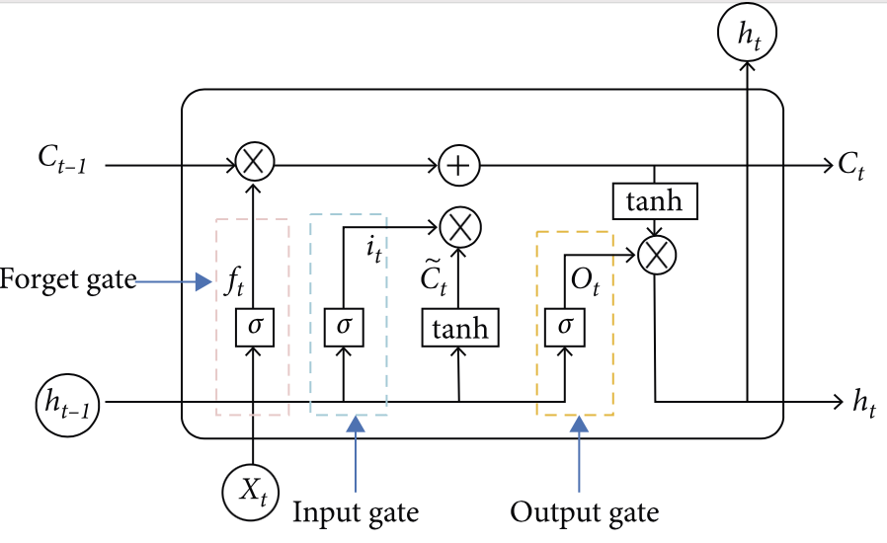
- CNN-LSTM structure for stock price prediction [5]

Buy and Sell Signals
When an investor decides to buy or sell a particular stock, he must get the best price. To achieve that, our web-application provides buy and sell signals using Moving Averages for all stocks in the Indian Stock Exchange. We construct a simple moving average window for 10 days and 60 days. When the 10-day moving average crosses the 60-day moving average, we indicate a buy signal. When the 60-day moving average crosses the 10-day moving average, we indicate a sell signal. This strategy is followed by traders all over the world. However, the moving average window may vary from trader to trader according to their strategy.
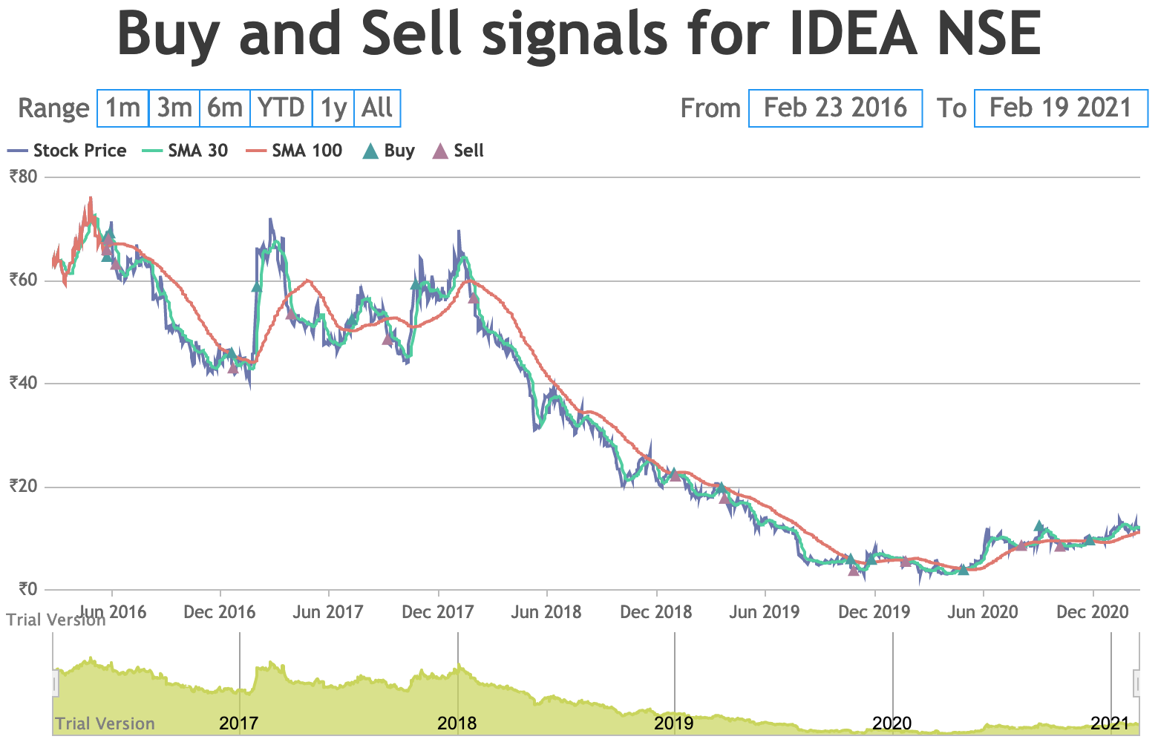
- Buy and sell signals for Vodafone Idea Limited in NSE
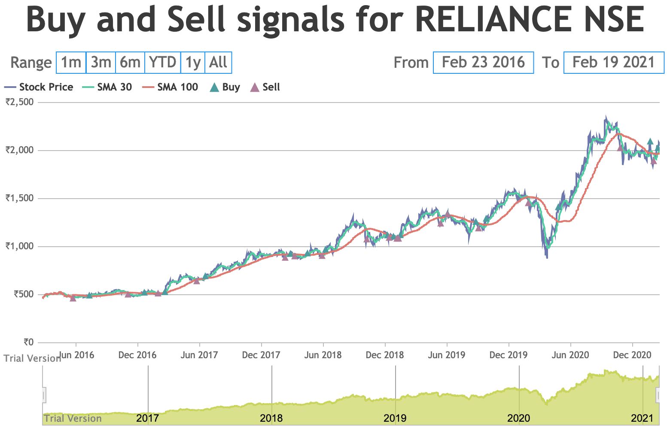
- Buy and sell signals for Reliance Industries in NSE

Prediction Results
The below figure (Figure 6) shows the previous closing prices of Reliance Industries (ticker: RELIANCE) listed on NSE India. The red line shows the predicted closing price for the same for the upcoming ten days.
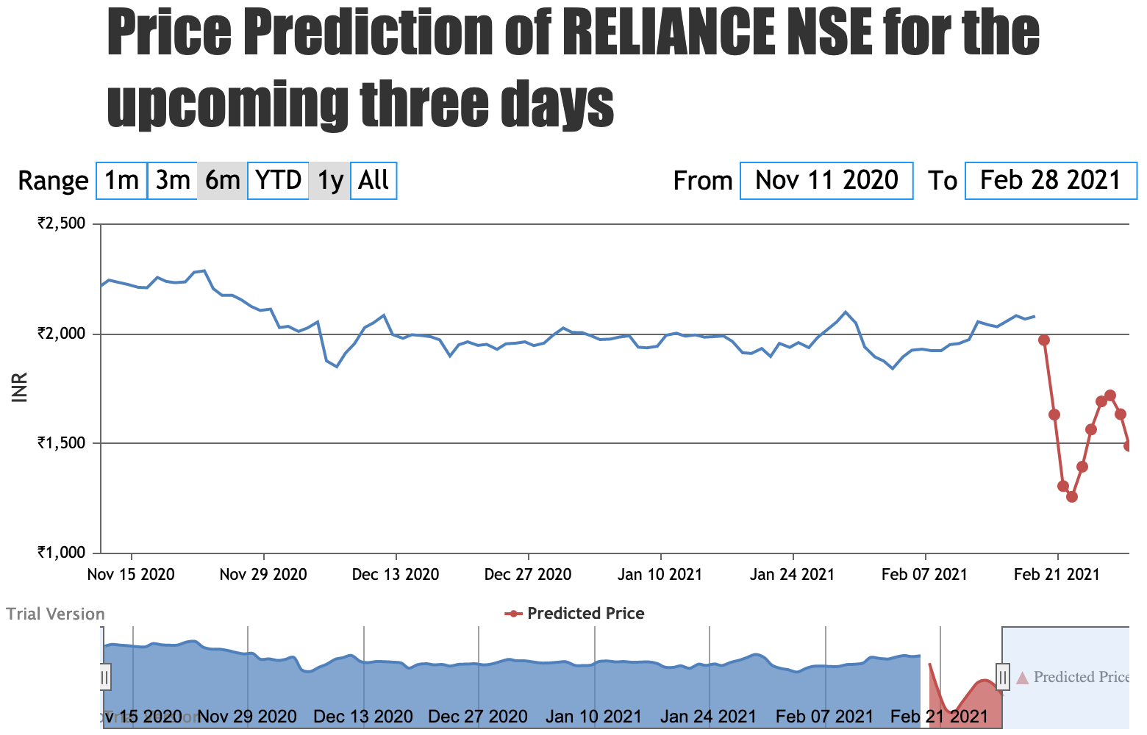
- Predicted closing price of Relisance Industries in NSE for the next ten days
The below figure (Figure 7) shows the previous closing prices of Vodafone Idea Limited (ticker: IDEA) listed on NSE India. The red dots show the predicted closing price for the same for the upcoming three days.
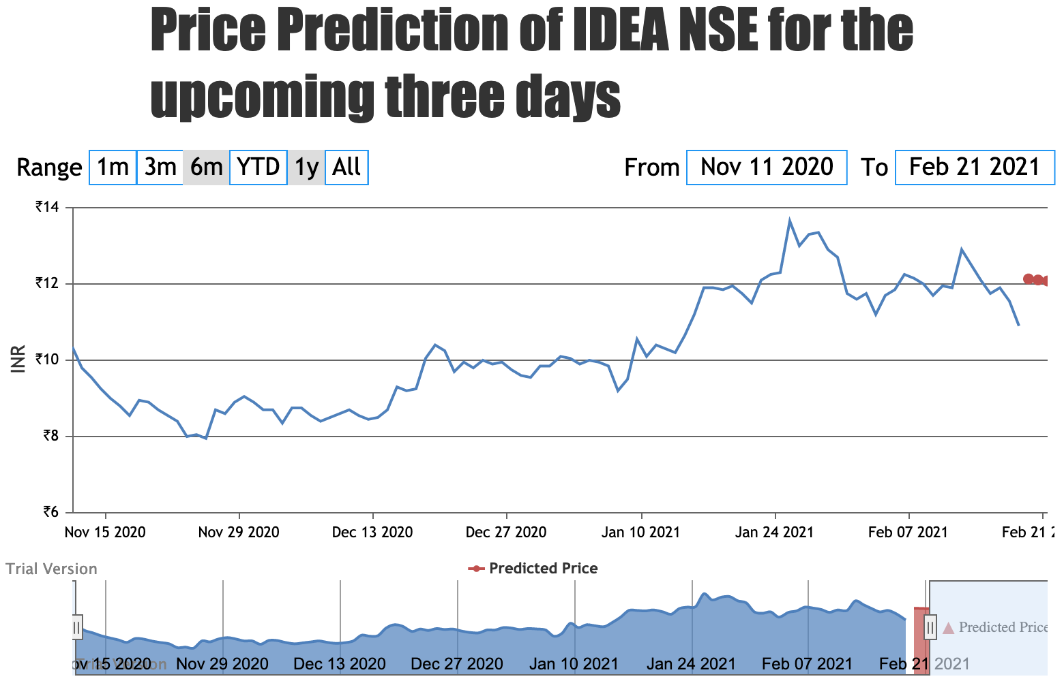
- Predicted closing price of Vodafone Idea Limited in NSE for the nect three days

Comparison with other models
We’ve compared our hybrid LSTM-CNN hybrid model with standalone CNN and LSTM models for Vodafone Idea Limited and Reliance Industries in NSE. The results are shown below.

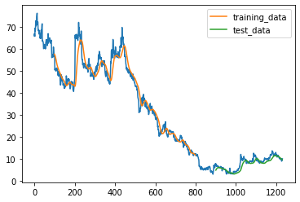
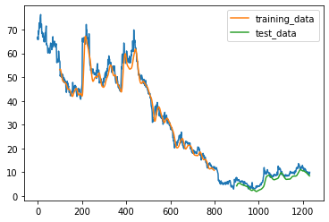
- Results obtained for Vodafone Idea Limited using CNN only
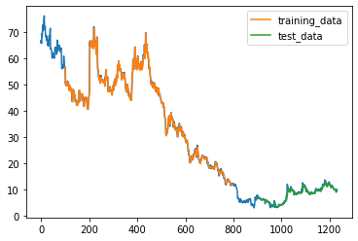
- Results obtained for Vodafone Idea Limited using LSTM only
- Results obtained for Vodafone Idea Limited using CNN-LSTM hybrid model
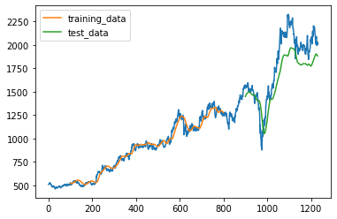
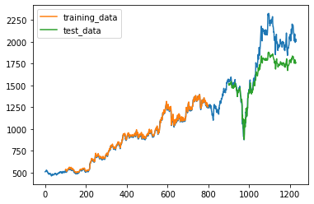
- Results obtained for Reliance Industries using CNN only

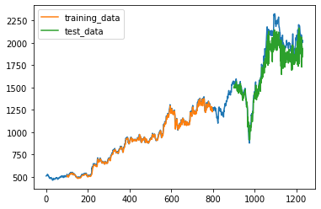
- Results obtained for Reliance Industries using LSTM only

- Results obtained for Reliance Industries using CNN-LSTM hybrid model
The results show that the performance of CNN-LSTM is the best among the three methods. The forecasts and R2 for CNN-LSTM were 0.90, respectively, increased by 2.8%, 0.55%, relative to the other two approaches.

Conclusion and Future Work
In this paper, we’ve discussed constructing a stock price prediction model using LSTM as well as RNN. This has overcome the drawback mentioned in the paper “Stock Price Prediction Using LSTM” [3] in the literature review. Price prediction has been done for 5 stocks listed in the Indian Stock Exchange out of which 2 are penny stocks and 3 are stable stocks. Algorithmic Trading has been demonstrated using Moving Averages, which is a key Technical Indicator used by professional traders. These features integrated into a web-application will help new investors and traders take the right decisions. However, the price prediction of stocks discussed in this paper does not take into account the effects caused by external factors such as news, financial events, press releases done by the company as they can drive the price of a stock drastically. This can be done as part of our future work by integrating a news aggregator which fetches the news related to a particular stock and finds whether the news is a positive or a negative news using sentiment analysis, Random Forest Algorithm, and identifying parameters like false positive, false negative, true positive and true negative into account and include those effects in the price prediction of the company’s stock.

References
- Penglei Gao ,Rui Zhang and Xi Yang, “The Application of Stock Index Price Prediction with Neural Network”, Multidisciplinary Digital Publishing Institute, 18 August 2020
- Padmaja Dhenuvakonda, R. Anandan, N. Kumar, “Stock Price Prediction Using Artificial Neural Networks”, Journal of Critical Reviews, 10 June 2020
- Raghav Nandakumar, Uttamraj K R, Vishal R, Y V Lokeswari, “Stock Price Prediction Using Long Short Term Memory”, International Research Journal of Engineering and Technology (IRJET), vol. 05 Issue: 03, March 2018
- R. Vanaga and B. Sloka, “Financial and capital market commission financing: aspects and challenges,” Journal of Logistics, Informatics and Service Science, vol. 7, no. 1, pp. 17–30, 2020.
- Wenjie Lu, Jiazheng Li, Yifan Li, Aijun Sun, Jingyang Wang, "A CNN-LSTM-Based Model to Forecast Stock Prices", Complexity, vol. 2020, Article ID 6622927, 10 pages, 2020.
- Hiransha M, Gopalakrishnan E.A, Vijay Krishna Menon, Soman K.P, “NSE Stock Market Prediction Using Deep-Learning Models”, International Conference on Computational Intelligence and Data Science, 2018

